**Merchant Integration Services**

E-Stamp: IN-DL67609269101270Q

## Please note that this form contains the details about your account and commercials for the services provided by PayU Payments Private Limited to you. Please sign this document and return to PayU along with specified documents for processing.

**Business Details**

## Business/Trading Name social networking forum

Legal Name social networking forum Business Filing Status/Legal Status Individual

PAN Details Website URL Android URL

!OS URL

Registered Address

Operating Address

**Contact Details '96 Business**

## Contact Name

Email Address Mobile Number

**Products and Services**

## Business Category

AAOTS9380F

<http://www.socialforumindia.com/index.php>

: NA

**: NA**

## 3rd Floor, Vitthal Charani Sankul, Off Big Bazaar, College Road

City: Nashik, State: Maharashtra, Pincode: 422005

3rd Floor, Vitthal Charani Sankul, Off Big Bazaar, College Road

City: Nashik, State: Maharashtra, Pincode: 422005

Pramod Gaikwad

[payal22k@gmail.com](mailto:payal22k@gmail.com) 9422769364

Social services And Governance

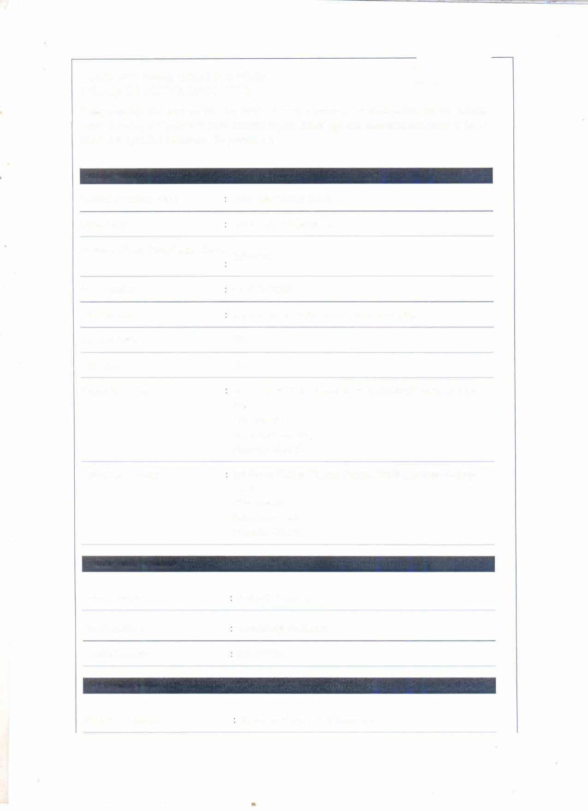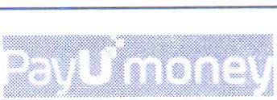

•

**PayU Products Opted** *:.',.* , , 1,

, · ' . ',

PayU Products Opted

Payl 1Money

**Bank Account Details**

Pay To Name SOCIAL NETWORKING FORUM

Bank Name STATE BANK OF INDIA

Account Number 34691906559

IFSC Code SBIN006043 I

Branch Address CROWN COMPLEX, OPP RAJIV G AN DHI BHAVAN, SHARANGPUR RODE, NASIK

City: NASHIK

State: MAHARASHTRA

**Commercial Details** •

Merchant shall pay to Payl 1 India

|  |  |  |
| --- | --- | --- |
| **S.NO.** | PARTICULARS | FEE |
| **A.** | Annual Maintenance Charge (AMC)* | Waived Off |
| **B.** | Security Deposit (interest free refundable) | Waived Off |
| C. | System Integration Fee (One time payable upfront at the time of | Waived Off |
| Signing of the Services Agreement.) i | |

..............,_.............,.._. ········ - ···········- ·· · -- •.-••--······

|  |  |
| --- | --- |
| S.NO. | TRANSACTION FEE |
| * | Credit Card Transactions (From Merchant) : 2.9% of the amo unt |
| * | Debit Card Transactions (From Merchant): 2.9% of the amo u nt |
| * | Net Banking Transactions (From Merchant): 2.9% of the amo u nt |
| * | AMEX Card Transactions (From Merchant): 3.0% of the amo unt |

**Terms and Conditions**

* All fees are exclusive of Service Tax and any other taxes/ levies, if a ny .
* Any waiver of AMC* shall be only for the first year comme nc i ng from Effect ive Date.
* The above rates are for Payment Instruments provided by PayU to Me rc hant are subject to approval from the Acquiring Bank.
* The Transaction Fees are inclusive of transaction processing fee, conv e n ie nce fe e, fee for value

added services, etc, subject to any additional fee charged separately.

* All compensation/consideration payments are in relation to Services rec e ived / to be received .

**Declaration by applicant**

We request PayU to set up the organization named above as a PayUMoney Me rcha nt/Selle r. We understand that the acceptance of this application is subject to approval by PayU. We unde rstand and agree that PayU has the right to reject this application for any reason whatsoeve r.

We certify that all information provided by us hereinabove is true and co rre ct.

We acknow le dge and accept that we have reviewed, read , understood and agree to abide by the PayU Agreement as defined and detailed in Annexure A. We accept all rights, obli g a tio ns, responsibilities and liabilities that may arise due to us becoming a PayUMoney Me rch a nt/Se ller including but not l im ited to rights, obligations, responsibilities and liabilities under th is Account Opening Form and the Online Terms and Conditions. We have also gone through the sc hed ule of commercials and there related terms and condition hereinabove and accept the sam e .

We understand and agree that PayU reserves the right to add/mod if y/ame nd/cha ng e any of the terms and conditions at any time without further notice to us. It is our res po nsib ili ty to review the Online Terms and Condition at regular intervals and comply with the same.

We further understand that ifwe require any clarifications with respect to the Pay U Agreement (including this Form), we may contact our PayU sales re prese ntat ive/acco u nt ma na ge r and they will connect us to the concerned PayU department.

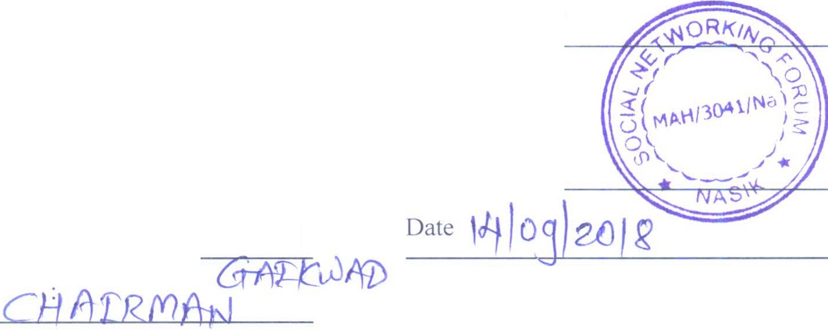

**Signature**

Organisation Stamp

Full Name

Pf½MoD *GopFtLJ2Ao*

Designation

**S:ocial Networking rorum**

**i:-hairman**

**Appro\'31** - **To be filled by PayU India officials only**

Signature '96 For and behalf of Payl India Organisation Stamp

'------------'I I'-----

Full Name Date

Designation

,

\,\ **1•'**

',

)'')._" .,; >,, 11'

*' 1* •· • '· *1' ;* '

**Date of Agreement**

### Date: 2018-08-30

**AnnexureA**

### PayU has agreed to provide and the Merchant has agreed to avail aggregate pay me nt gateway solutions with respect to the Merchant Site ('PayU Services') in accor danc e with this Form, the terms and conditions detailed hereunder and the terms and conditions ava ilab le on li ne at https://[www.payumoney.com](http://www.payumoney.com/) /PayUM oney _tnc .htm l for PayUMoney Prod ucts (' PayUMoney Terms and Conditions') and at https://www.payu. i n/term sandc ond itions for Pay U Biz products ('PayU Biz Terms and Conditions'); depending upon the PayU Produc t opted for by the Mercha nt in this Form ('collectively PayU Agreement').

* 1. The Merchant understands that the PayU Agreement constitutes an ag reemen t between the Parties with respect to availing PayU Services. The Merchant acknowledges and agree s that the PayU Agreement is duly stamped and is legal binding upon the Merchant and Pay U. The stamp duty has been paid by PayU.
  2. The Merchant explicitly acknowledges and agrees that the Merchant has read, reviewed and

understood the PayU Agreement.

* 1. Except where the context otherwise requires or where explicitly defin ed, the capitali zed terms in the PayU Agreement shall have the meaning ascribed to it in the Pay U Biz Terms and Conditions and PayUMoney Terms and Cond itions, respectively.
  2. Scope of PayU Services:
     1. The Merchant has established the Merchant Site to sell the Prod uc ts and /or collect payments online from the Customers.
     2. PayU will act as an intermediary by creating a link between the Me rcha nt Site and the respective Acquiring Banks Services by means of its Software Ap plic ations and the PayU Pla tform; thereby enabling the Customers to make payment of Custome r Charge on the Merchant Site through Acquiring Bank's Services using various Paym e nt O ptions ("Internet Payment Gateway").
     3. In order to serve in this role, PayU has entered into agreements wit h var ious Acqu iring Ban ks to enable use of Payment Systems operated by such Acquiring Ba nks in orde r to process payments using Acquiring Bank Services.
     4. Once the payment instruction is Authenticated and Authorized through the Acqu iring Bank Serv ice s, the Acquiring Bank will transfer such approved Cust ome r Charg e from the Customer Bank Account to the Nodal Account.
     5. The Merchant directs and authorizes PayU to rece ive, hold, dis bur se and settle the Customer Charge in accordance with and subject to the provisions of the Pay U Terms and Conditions.
  3. Term: The Agreement shall be in force from the date of acceptance of this Form by PayU and shall

remain in force until terminated by either Party in accordance with the prov isi ons of the PayU Agreement.

* 1. The Merchant undertakes that the Merchant has disclosed the exact bus ine ss category/bus iness

sub-category for which the Merchant will be using the PayU Serv ice s . In order to use the PayU Services for any other purpose, the Merchant understands and ackno wle dges tha t it shall notify

PayU in writing of such change and such change will be subject to app rova l by Pay U. PayU may terminate this Agreement forthwith, in the event the Merchant breaches this c la use .

* 1. In consideration for PayU Services, the Merchant agrees to pay PayU, Fees as de ta il e d in the Fee

Schedule above. The Transaction Fee ('TDR') shall be deducted by PayU from the Customer Charge payable to the Merchant in respect of each completed Transactio n. PayU res e rves the right to revise the Fee periodically, and PayU will intimate the Merchant of any such change within reasonable time.

* 1. Subject to any other Clause of the PayU Agreement, PayU shall endeavour to i nstruct the Nodal Bank to transmit the Settlement Amount from the Nodal Account to the Mercha nt'92s Bank Account within the time period prescribed by Reserve Bank of India.
  2. PayU hereby declares, assures, undertakes and covenants as under:
     1. PayU is certified Payment Card Industry Data Security Standard ('PC! DSS').
     2. PayU shall comply with all Applicable Laws in offering the PayU Se rv ices.
     3. In the event that Merchant complaints or is dissatisfied with PayU Serv ices, Pay U shall make reasonable efforts to resolve the same.
     4. PayU shall attend to complaints/queries raised by Merchants with res pect to Pay U Services during business hours on Business Days.
     5. PayU shall endeavor to provide technical assistance to Merchants during busi ne ss hours and Business Days.
  3. The Merchant shall in writing inform PayU of all changes in its co ns titut io n, directors/partners/trustees, or change in the registered or corporate addresses of each office, within seven (7) Business Days of such change having taken place; listing out the nam es and details of the personnel in charge of the management and affairs of the Merchant. Suc h int i ma tio n shall be provided on the Merchant's letterhead signed by the authorized signatory of the Merchant.
  4. In the event that PayU was providing PayU Services for the website currently de fi ned as Merchant

Site, under a different arrangement/ ownership/ branding, prior to this Ag reeme nt , the Merchant hereby agrees to indemnify and hold harmless PayU and/ or the Acq uiri ng Ba nks for any losses, costs, damages, penalties, Chargebacks, refund overdraft, or credit proble ms s uffe red or incurred for the services provided to the said website under the erstwhile agreement. It is hereby clarified that the Parties may mutually agree in writing to waive off the app lica bili ty of th is clause. Further it is clarified that this clause will not be applicable in the event PayU was not pro v id ing PayU Services to the Merchant Site, prior to this Agreement.

* 1. The Merchant acknowledges that if PayU was providing PayU Services to the Me rchant Site under a different arrangement *I* ownership/ branding, prior to this Agreeme nt, the me rcha nt understands that PayU will start settling the funds to the Merchant's bank account on ly aft e r the Merchant gets registered with PayU's Acquiring Banks and Nodal Banks and the same has bee n confirmed to the Merchant by PayU. For the transactions prior to the said event shall be co nt in ued to be settled in accordance with the previous agreement for the said website.
  2. The PayU Agreement may be terminated by either Party by giving 30 (thirty) days prior written notice to the other Party. However, PayU sha l l terminate the PayU Ag reeme nt fo rthw ith, if the Merchant fails to perform its obligations under or is in breach of any terms of the PayU Agreement.
  3. Except as provided in the PayU Agreement, no other rights are grante d to the Me rc ha nt or to any third party by PayU with respect to PayU Services availed by the Mer cha nt. Pay U shall not be liable to the Merchant in any manner whatsoever, except as provided in the Pay U Agreement.
  4. We understand and agree that PayU reserves the right to change any of the Pay U Biz Terms and

Conditions and PayUMoney Terms and Conditions without further no tice to t he Merchant. It is the responsibility of the Merchant to review the PayU Agreement at reg ular i nte rvals and comply with

# •



### the same.

Registered Address

### 32, Viraj Buil ding , SY Road, above HDFC Bank, Khar West, Mumbai, Maharashtra, Pin - 400052

Corporate Address

### PayU Payments Private Limited 9th Floor, Bestech Business Tower , Sector 48, Sohna Road, Gurgao n,

Haryana, Pin - 122002 [www.payumoney.com](http://www.payumoney.com/)

•